Enterprise Europe Network is the largest network in Europe supporting SMEs competitiveness and innovation. Thanks to its 600 contact points (Chambers of Commerce, Regional Development Agencies, Technology Centres) in 50 countries across Europe and beyond, it helps SMEs develop their innovation potential and access new markets. Launched in 2008 by the European Commission, it represents an integrated services system: to help SMEs to meet new business and technological partners abroad; to boost innovation and technology transfer; to promote the participation in R&D European programmes.

Unioncamere Emilia-Romagna, Eurosportello – Chamber of commerce of Ravenna and Aster belong to the network within SIMPLER Consortium.

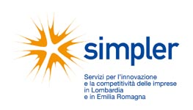
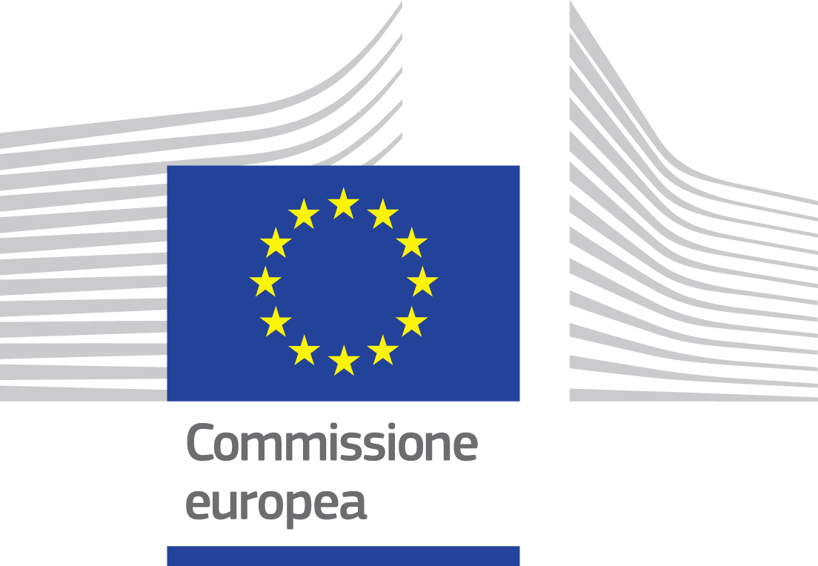



BROKERAGE EVENT
AT MACFRUT 2014

24-25 September 2014
Cesena –Italy

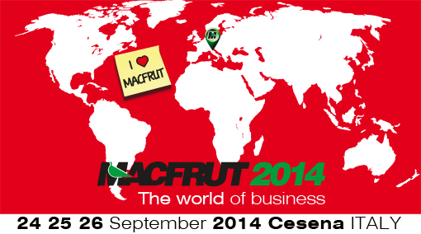

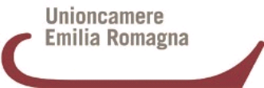

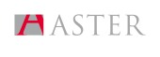
B2B meetings at MACFRUT 2014
- Register your company and fill in your
company profile on the website http://www.b2match.eu/macfrut2014 within 29th August 2014
- Select companies with profiles responding to your needs from the online catalogue
- Submit meetings’ requests from 3th to 16th September 2014
- Before the event individual agenda with all prearranged meetings will be sent by email



FREE OF CHARGE SERVICES

- Hotel accommodation for 3 nights
- Entry ticket and catalogue - Macfrut fair
- Interpreting service during the meetings (if required)
- Participation in B2B meetings and
company visits
- Free shuttle service from Bologna airport

For further information:

Unioncamere Emilia-Romagna
Phone: +39 051 6377034
valentina.patano@rer.camcom.it
www.ucer.camcom.it/enterprise-europe-network/een

25 September 2014

8.30 am | Meeting in the Hotel hall
8.45 | Transfer by bus to MACFRUT2014
09.00 am | Free visit to Exhibition
10.00 am | B2B meetings with exhibitors
1.00 pm | Lunch buffet
1.30 pm | B2B meetings with exhibitors
4.00 pm | Meeting at the bus stop located at the entrance of the Exhibition
4.30 pm | Cultural visit ( to be defined)
6.00 pm | Meeting at the bus stop  located at the entrance of Exhibition and transfer to the hotel

26 September 2014

Personalised transfer to Bologna airport

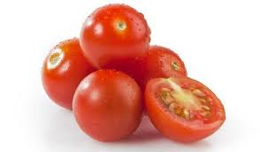

. PROGRAMME

23 September 2014

Delegation arrival at Bologna airport and transfer to the hotel

24 September 2014

8.30 am | Meeting in the Hotel hall
8.45 am | Transfer by bus to MACFRUT2014
9.00 - 9.30 am | Registration at EEN Lounge
10.00 am | B2B meetings with exhibitors
1.00 pm | Lunch
1.30 pm | B2B meetings with exhibitors
4.05 pm | Meeting at the bus stop located at the entrance of the Exhibition
4.15 pm | Company visit ( to be defined)
6.00 pm | Transfer to the hotel
8.00 pm | Meeting in the Hotel hall and transfer to have gala dinner
8.30 pm | Gala dinner

MACFRUT is the International Exhibition of Plants, Technologies and Services for the Production, Conditioning, Marketing and Transport of Fruit and Vegetables. The 31th edition of MACFRUT will take place from 24th to 26th September 2014 in Cesena (Italy).

The exhibition is the most important in Italy and it has become very famous worldwide, as a meeting point for the professionals of the sector. From production to processing, from packaging to marketing, from technology to logistics: hundreds of companies will present their new products at Macfrut 2014, where, for three days, it will be possible to meet companies and professionals from all over the world, to see the developments of the technologies of the sector and to take part in important workshops and conferences.

Topics

- Seeds, Fruit-Vegetable-Flower Growing
- Machines and Technical Equipment for Production
- Fruit and Vegetable Production
- Machines and Technologies for Selection,
Packaging and Preservation
- Packaging: Materials and Packages
- Fruit and Vegetable Marketing
- Logistics and Transport
- Services

Key Figures MACFRUT 2013:

- Exhibition area: more than 30.000 square meters.
- 819 exhibitors
- 24.788 visitors
- More than 30 conferences
- 483 business meetings
- 80 foreign official delegations

Key Figures Brokerage event at MACFRUT 2014:

- 7 countries represented :
Italy, Poland, Israel, Hungary, Bulgaria, Russia, Turkey
- 191 participants
- 300 transnational meetings

